**TEAM #4 - CareConnect**

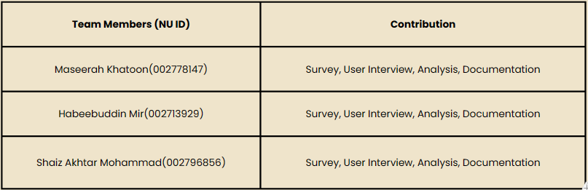

# 1. GENERAL INFORMATION

1. How did you identify the requirements and needs (observation, review tools etc.)? Why did you choose that method?

We identified requirements by conducting in person and online interviews where 10 participants were asked to perform basic tasks like booking a doctor’s appointment, reaching out to their doctors and researching information about new doctors. A team member of ours asked questions, the other observed behavior and the third recorded and made notes. At the end participants filled out forms.

1. How did you record your findings?

We used note taking apps like Notion to record data, phone cameras and zoom meetings to record behavior. We also leveraged google forms to conduct pre and post interview surveys which helped us generate crucial graphs and tables.

# 2. USER PROFILES

We have divided our pool of participants into two categories. One that requires routine health checkup and the others

1. User type 1: Routine Health
   1. User description: Adults from diverse backgrounds and high technical proficiencies. Includes patients requiring occasional medical care. Mostly young adults.
   2. Use case scenario: Research and book Appointments
   3. Tasks -

U1T1: Find a suitable Doctor

U1T2: Book an appointment

U1T3: Communicate with Doctor

1. User type 2: Chronic Illness Management
   1. User description: Adults from diverse backgrounds and low technical proficiencies. Includes patients requiring regular medical care. Mostly seniors.
   2. Use case scenario: Book appointments and maintain health records
   3. Tasks -

U2T1: Book regular appointments

U2T2: Maintain and securely share health records

U2T3: Join online appointments

# 3. NEEDS

Refer to the “User needs assessment requirements” excel sheet for more details*.*

# 4. REQUIREMENTS

Refer to the “User needs assessment requirements” excel sheet for more details.

# 5. USE CASE DIAGRAMS

